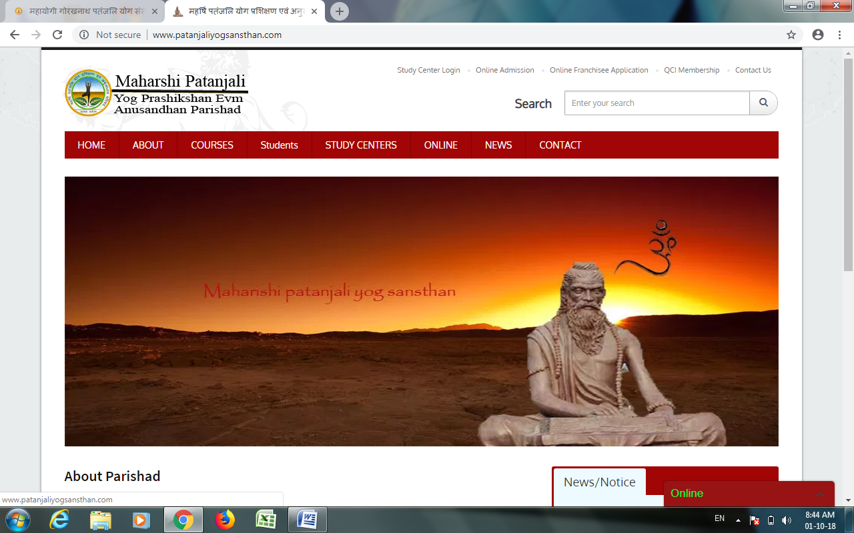

About Parishad

Nice Yog Shikshan Evam Prashikshan Sansthan is founded and run by Nuva of Computer education Society, An Autonomous Body registered by Govt. of UP  under SR Act, 1860, and affiliated with various Govt. and Non-Govt. organizations to run respective professional and vocational training couses. Nuva of Computer education Society is working last 19 year in various fields social work like Education, Yoga & Wellness, Environment and poverty elimination etc.

Education takes place when, the person is open to any new learning experience at any age, time and place with an open mind.

A Brief History Of Yoga

Yoga: the trendy practice that your hippie, hipster, or fitness friends rave about. Garbed in yoga pants and carrying colorful mats bought off Amazon, the modern-day “yogi” attends one-hour classes that focus on physical stretching, movement, and detoxing from their busy modern lives. We hear a lot about the benefits of yoga, from its ability to decrease stress, chronic pain, as well as the risk for chronic diseases like obesity, diabetes, and heart disease.

What we don’t hear about as often, however, is the history of yoga. Most people are aware of its Indian spiritual and religious roots, but those tend to get washed out by the manufactured, commoditized versions of yoga we see today. Perhaps that’s because research on yoga’s origins is hard to find, and its history is a complicated, lengthy narrative. In fact, yoga is incredibly complex — even the word "yoga" has taken on hundreds of different meanings and practices throughout the years. What you and I might assume is “[yoga](http://patanjaliyogsansthan.com/)” is probably not even closely related to what yoga was thousands of years ago.

**OUR PHILOSOPHY**

We believe that every one should try for his spiritual progress but at the same time he should work for the good of others. Swami Vivekananda was to put this aim before his disciples. Yoga also be helpful in improving the quality of the individual. But it should also equip him to help others who are in need. So through practicing Yoga individuals will get physical fitness, energy, peace of mind etc .

**OUR MOTIVATION**

Yoga is playing a vital role in the new millennium. Some people use their Sidhis (special powers) from yoga, to make money through showing magic. So common man is misguided or mislead by many of the pseudo yogis. Our mission is to propagate original yoga among people. The first step to this is to prepare good yoga teachers (Yoga Acharyas) with clear vision about Patanjali Yoga .

**OUR AFFILIATION**

Nice Yog Shikshan Evam Prashikshan Sansthan is approved by Ministry of Ayush and certified by Quality Council of India (QCI).

COURSES

Code: **PGDY** Duration **15 Months** Eligibility : **Graduation**

Code: **DY** Duration **12 Months** Eligibility : **10+2 or Eq.**